Executive position Summary
Exec applications are due dates:
President Positions - Friday January 26th
All other positions - Friday February 16th
email to; outdoorclub.mac@gmail.com with subject heading “Exec Application 2018”

MOC Exec Layout
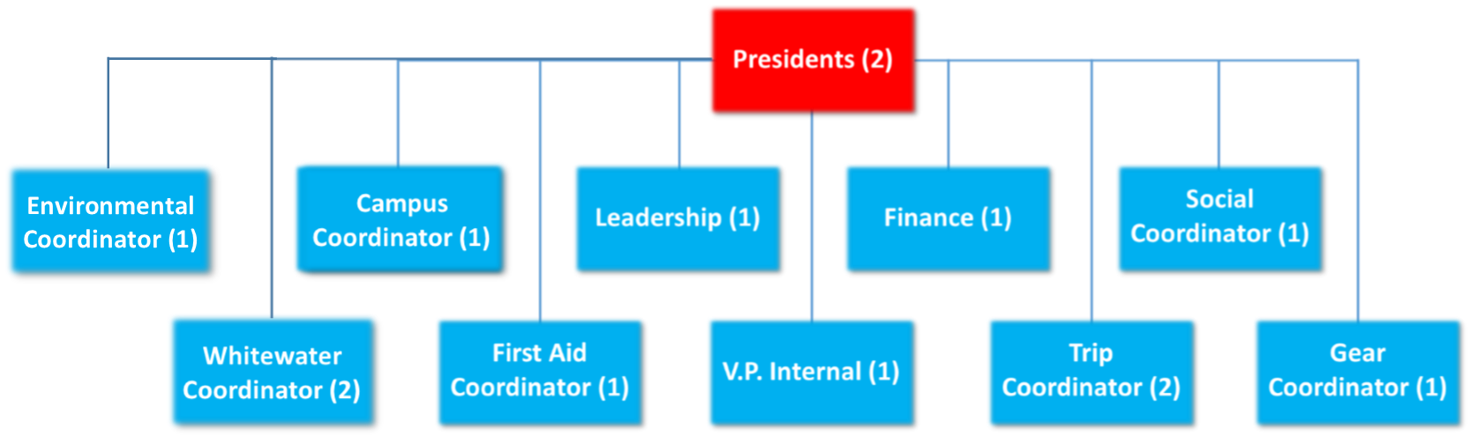
TIME COMMITMENTS: all executives are responsible for attending Weekly Exec meetings which last an hour. On top of this an Exec will have anywhere between 1-many h/week of work. Depending on the week (sometimes you don’t have anything, sometimes you have a lot).

Presidents - 2 Positions
The club presidents oversee all executive team portfolios and all club activities. Their responsibilities include:
- Coordinating weekly exec meetings
- Managing and distributing roles among the executive
- Holding weekly office hours
- Coordinating club activities with Wayne and Athletics & Recreation
- Evaluating all trip itineraries/ budgets
- Evaluating overall club budgets & approving club spending
- Assessing/ amending any club protocol as necessary
- Addressing unforeseen circumstances
- Assuming additional responsibilities as needed
- Be visible and available at club events (1 president should attend each event)
- Provide mid-year executive feedback
- Manage sponsorships and partnerships
- Responsible for engaging leaders in the Nature at Mac Sunday Hike Series

V.P. Internal- 1 Position:
The VP internal is aware of all club activities and keeps all club members informed of club initiatives. Their responsibilities include:
- Marketing all trips/events
- Recording executive meeting minutes
- Creating & sending club news letters
- Responding to/ forwarding all email enquiries as appropriate
- Managing the club website
- Managing all club social media and promotions

Trip Coordinator - 2 Positions:
The Trip Coordinator focuses on overseeing all the overnight trips run by the club. Major trip planning responsibilities are those of Algonquin, Reading Week/Winter Break trips and Dog sledding. The trip coordinator is then responsible for filling the schedule with other trips and finding leaders or other executive members to do the organization:
- Plan trips
- Advertise Trips
- Open trips for registration
- Oversee the planning of trips
- Assure safety protocols are followed and explained to leaders
- Find leaders to run and plan trips
- Find exec members to plan and lead trips
- Create trip schedule before each term

Gear Coordinator - 1 Position:
The Gear Coordinator has the responsibility of assuring that equipment and first aid equipment is signed out properly and returned properly. Responsible for assuring that equipment is able to go back on trip:
- Sign in/out gear before and after trips
- Repair gear when required
- Replace gear when required
- Assure that gear is stored is a manner that will not result in increased wear
- Create club inventory

First Aid Coordinator - 1 Position:
The First Aid Coordinator has the responsibility of assuring that first aid equipment is stocked and able to go back on trip:
- Stock First Aid Equipment
- Plan/Book Wilderness First Aid Course (run in April)
- Responsible for creating and running first aid refreshers (1 per term)
- Purchase medication and medical supplies
- Responsible for working closely with an EFRT representative

Social Coordinator - 1 Position:
The Social Coordinator is responsible for organizing socials and events relating to the outdoors club and the greater McMaster community:
- Schedule and organized weekly outdoors club related events
- Schedule and organize Beginning and end of year socials
- Advertise events on social media

Finance – 1 Position:
Our finance coordinator manages club finances and assists trip planners with trip budgeting. Their responsibilities include:
- Filing monthly diners club statements
- Providing weekly finance updates
- Being available to assist leaders with trip budgeting
- Being available to assist with fundraising/sponsorship initiatives

Leadership- 1 Position:
Our leadership coordinator acts as a liaison between the executive and leaders and assists with leader recruitment and training. Their responsibilities include:
- Planning leadership events/ socials
- Receiving and assessing leadership applications
- Assisting with the creation/ dissemination of leadership resources
- Coordinating leadership recruitment
- Seeking opportunities for leadership development
- Maintaining connections with club alumni
Campus Coordinator – 1 Position:
Our campus coordinator works to improve campus relations and promotions for the Outdoor Club. They works to recruit new members and work to promote the club on campus, with other clubs, and with the greater Hamilton community.
- Works closely with our Social Coordinator
- Acts as a liaison between the club and first year students
- Creates posters for Outdoor Club events and works to post them around campus
- Works to recruit new members to the club and promote events and trips

Environmental Coordinator – 1 Position:
Our environmental coordinator works alongside Nature at Mac to deliver environmental programming to the club and greater campus community. They are involved with planning and running environmental events, workshops, and cleanups.
- Works closely with Nature at Mac and sits on their environmental council (weekly meetings)
- Advertise environmental events and topics on social media
- Schedule and run environmental outdoor club events and workshops
- Help schedule and run Cootes cleanups along with Nature at Mac (around 1 per term)
- Helps run and organize the Nature at Mac Sunday hike series
- Helps Nature at Mac organize and run stewardship hikes
Whitewater Coordinator – 2 Positions:
Our Whitewater coordinators are responsible for running our weekend whitewater pool sessions and workshops. The coordinators also work to create and run whitewater trips (canoeing, rafting, or kayaking) for the club.
- Approximately 5-6 pool session per term, run on Sundays (pool sessions are from 2:30-4:00pm)
- 0-1 kayak workshop per term depending on availability
- Manage the whitewater club facebook page
- Responsible for whitewater promotion
- Responsible for whitewater club gear and maintenance
- Whitewater certifications preferred; whitewater experience required

McMaster Outdoor Club (MOC) Executive Application for 2018/19
Exec applications are due Friday February 16^{th/}
Email to; outdoorclub.mac@gmail.com with subject heading “Exec Application 2018”
Please attach an updated resume along with the application bellow

Name: |  | Email:
Phone Number:

Current Program: |  | 2018-2019 Program year:
Will you be graduating next year?

Why do you want to be on the MOC Executive

Describe any leadership experience, positions, and responsibilities that you think will be valuable to the club.

Favourite outdoor activity
Dream trip
Biggest fear

Please choose three positions that you would like to participate as on the 2017-2018 MOC Executive. Choose them in the order of your interest, 1st being the most desired and 3rd, still something you’d like to do!

 | Position | What qualifications will you bring to the position | Why do you want to take on this position
#1
#2
#3

Insert a picture of YOU.
Also please attach a proper jpeg pic of you with the email.
(can be of you doing something outdoorsy, you on a trip, or anything appropriate)

