Executive position Summary
Exec applications are due dates:
President, VPI, VPE, Environmental – Not Accepting This Year
All other positions - Sunday March 29th by 11:59pm
email to; outdoorclub.mac@gmail.com with subject heading “Exec Application 2020”

MOC Exec Layout
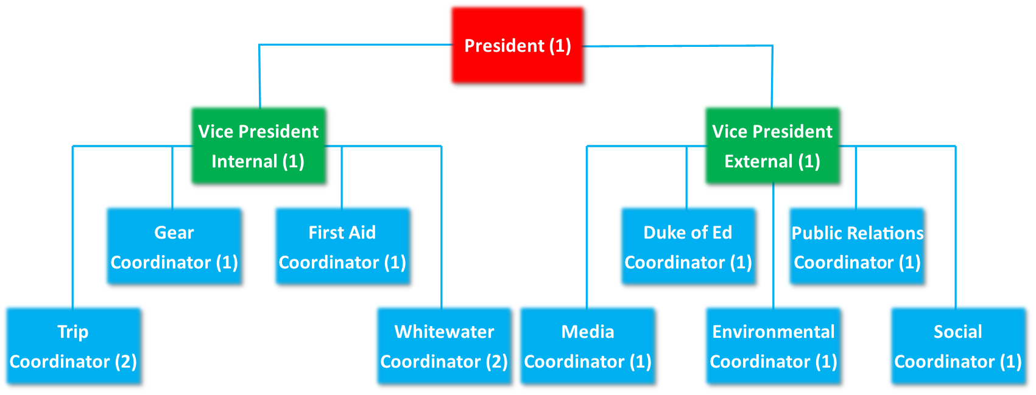
TIME COMMITMENTS: all executives are responsible for attending Weekly Exec meetings which last an hour. On top of this an Exec will have anywhere between 1-many h/week of work. Depending on the week (sometimes you don’t have anything, sometimes you have a lot). Additional meetings/commitments may be necessary for certain positions.

Only positions listed below are currently open for application:
Trip Coordinator - 2 Positions:
The Trip Coordinator focuses on overseeing all the overnight trips run by the club. Major trip planning responsibilities are those of Algonquin, Reading Week/Winter Break trips and Dog sledding. The trip coordinator is then responsible for filling the schedule with other trips and finding leaders or other executive members to do the organization:
- Plan trips with the VP Internal and anyone with a cool trip idea
- Assure safety protocols are followed and explained to leaders
- Assess leader needs for each trip
- Create trip schedule before each term
- Write up the emergency response plan for each trip with trip leaders
- Be present at pre-trip meetings
- Manage the trips email

Gear Coordinator - 1 Position:
The Gear Coordinator has the responsibility of assuring that equipment and first aid equipment is signed out properly and returned properly. Responsible for assuring that equipment is able to go back on trip:
- Sign in/out and get gear ready before and after trips
- Repair gear when required
- Replace gear when required
- Assure that gear is stored is a manner that will not result in increased wear
- Manage club inventory
- In charge of renting gear
- Manage the gear email

First Aid Coordinator - 1 Position:
The First Aid Coordinator has the responsibility of assuring that first aid equipment is stocked and able to go back on trip:
- Stock First Aid Equipment
- Plan/Book Wilderness Advanced First Aid Course with President (run in Fall and Spring)
- Responsible for creating and running first aid refreshers (1 per term)
- Purchase medication and medical supplies
- Manage Epi-pen protocols
- Responsible for working closely with an EFRT representative, if not already a member of EFRT
- Preference given to those already on EFRT and returning to EFRT for the 2020-2021 year

Whitewater Coordinator – 2 Positions:
Our Whitewater Coordinators are responsible for running our weekend Whitewater pool sessions and workshops. The coordinators also work to create and run Whitewater trips (canoeing, rafting, or kayaking) for the club.
- Approximately 5-6 pool session per term, run on Sundays (pool sessions are from 2:00-3:30pm)
- 0-1 kayak workshop per term depending on availability
- Manage the whitewater club Facebook page
- Responsible for whitewater promotion
- Responsible for whitewater club gear and maintenance
- Whitewater certifications preferred; whitewater experience preferred

Social Coordinator - 1 Position:
The Social Coordinator is responsible for organizing socials and events relating to the outdoors club and the greater McMaster community. They works to recruit new members through events and work to promote the club on campus, with other clubs, and with the greater Hamilton community.

- Schedule and organized weekly outdoors club related events/socials
- Schedule and organize Beginning and end of year socials
- Attend/run most socials, or work to have another member of the club run the event
- Assist VPI and President on scheduling and planning leader socials
- Advertise events on social media with the Media Coordinator
- Assist Media Coordinator in the creation of posters for events/socials

Media Coordinator - 1 Position:
The Media Coordinator is responsible for all things social media within the club posting to Instagram Facebook and our monthly emails. They work closely with all exec members specifically the VP Internal and External:
- Creating a monthly email newsletter and sending it out
- Posting trip photos before/during and after trips
- Creates posters for Outdoor Club events and works to post them around campus
- Works to recruit new members to the club and promote events and trips
- Answer the club general email and messenger on Facebook
- Manages the clubs Facebook, Twitter, Instagram, and Website with the VPE and President

Duke of Edinburgh Coordinator – 1 Position:
The Duke of Ed Coordinator teaches people about the Duke of Ed program and helps them apply for it and complete their steps in the program.
- Hold two seminars about the Duke of Ed program(fall/winter)
- Help McMaster students sign up for Duke of Ed
- Be at club fest to get people to sign up for Duke of Ed
- Advertising the Duke of Ed program to McMaster students
- Manage McMaster’s Duke of Edinburgh program; including helping other students with their Duke of Ed work, keeping track of the database, advising students on their awards progress, admin work related to the program
- Preference given to those with prior Duke of Ed experience
- This position extends beyond the McMaster Outdoor Club to the entire McMaster University student body. It is an external volunteer position run through the club, but covers all students interested in the Duke of Ed program

Public Relations Coordinator – 1 Position:
The Public Relations Coordinator is in charge of all outreach outside the university. This role will be in communication with other outdoor clubs from other universities and promote outdoor events to our members. They will also be tasked with communicating with sponsors and companies to receive sponsorships and deals.
- Works closely with VPE, VPI, and President
- Being available to assist with fundraising/sponsorship initiatives
- Assisting with the creation/ dissemination of leadership resources
- Seeking opportunities for leadership development
- Maintaining connections with club alumni
- Communicating with outside bodies
- Ensuring that we maintain our sponsorships
- Help manage the club admin email
- Work to communicate between other clubs on campus
- Plan fundraisers throughout the year (at least 1 per term)

McMaster Outdoor Club (MOC) Executive Application for 2020/21
Exec applications are due Sunday March 29th by 11:59pm
Email to; outdoorclub.mac@gmail.com with subject heading “Exec Application 2020”
Please attach an updated resume along with the application bellow

Name: |  | Email:
Phone Number:

Current Program: |  | 2020-2021 Program year:
Will you be graduating next year?

Why do you want to be on the MOC Executive

Describe any leadership experience, positions, and responsibilities that you think will be valuable to the club.

Favourite outdoor activity
Dream trip
Biggest fear
If you were a fruit, what fruit would you be?

Please choose up to three positions that you would like to participate as on the 2020-2021 MOC Executive. Choose them in the order of your interest, 1st being the most desired and 3rd, still something you’d like to do!

 | Position | What qualifications will you bring to the position? | What would you do/bring to this position?
#1
#2
#3

Insert a picture of YOU.
Also please attach a proper jpeg pic of you with the email.
(can be of you doing something outdoorsy, you on a trip, or anything appropriate)

