Executive position Summary
Exec applications are due dates:
President, VPE, Senior Environmental, Gear, First Aid – Not Accepting This Year
All other positions - Sunday March 21st by 11:59pm
email to; outdoorclub.mac@gmail.com with subject heading “Exec Application 2021”

MOC Exec Layout
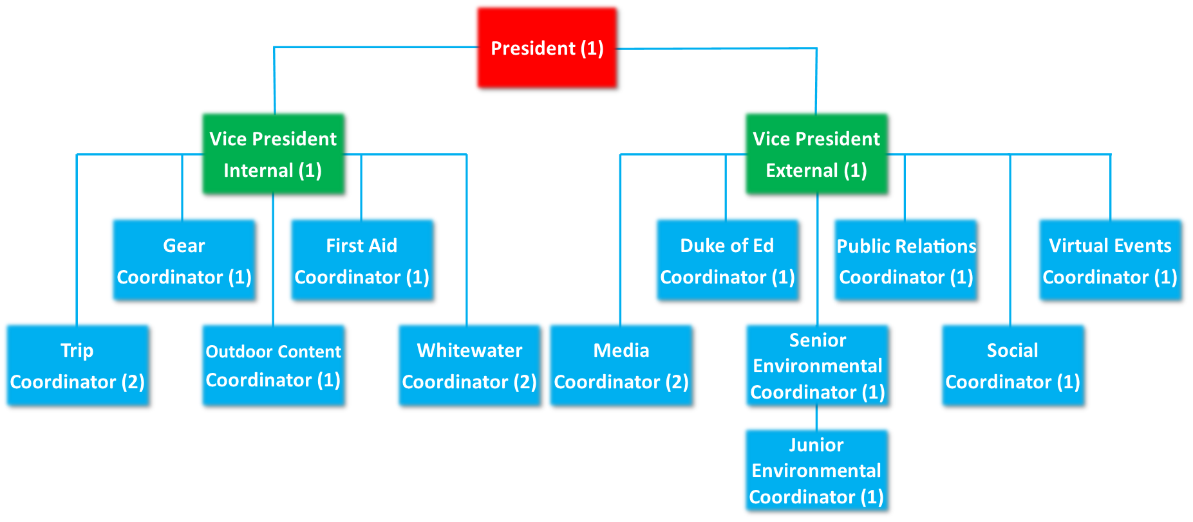
TIME COMMITMENTS: all executives are responsible for attending weekly Exec meetings which last an hour. On top of this an Exec will have anywhere between 1-many h/week of work. Depending on the week (sometimes you don’t have anything, sometimes you have a lot). Additional meetings/commitments may be necessary for certain positions.

Only positions listed below are currently open for application:
Trip Coordinator - 1 Position:
The Trip Coordinator focuses on overseeing all the overnight and day trips run by the club. Major trip planning responsibilities are those of Algonquin, Reading Week/Winter Break trips and Dog sledding. The trip coordinator is then responsible for filling the schedule with other trips and finding leaders or other executive members to do the organization:
- Plan trips with the VP Internal and anyone with a cool trip idea
- Assure safety protocols are followed and explained to leaders
- Assess leader needs for each trip
- Create trip schedule before each term
- Write up the emergency response plan for each trip with trip leaders
- Be present at pre-trip meetings
- Manage the trips email

Outdoor Content Coordinator – 1 Position:
The Outdoor Content Coordinator is responsible for the creation of content for workshops, trip leaders, our website, guidebook, etc. It will involve taking outdoor skills, information, maps, etc. and converting it into easy to share formats across MOC’s offerings.
- Work on the development of MOC’s outdoor skills guidebook
- Work to develop outdoor skills and content for MOC’s website
- Work to create skills and outdoor resources for MOC’s leaders
- Map development and creation for MOC trips
- Organizing and digitizing MOC’s paper resources (Maps, books, etc.)
- Assist the Social Media Coordinators in creating outdoor skills posts for our social media platforms
- Assist the Gear Coordinator with developing how to video guides for MOC’s equipment
- Other duties as assigned

Whitewater Coordinator – 2 Positions: This position is COVID dependent
Our Whitewater Coordinators are responsible for running our weekend whitewater pool sessions and workshops. The coordinators also work to create and run whitewater trips (canoeing, rafting, or kayaking) for the club.
- Approximately 5-6 pool session per term, run on Sundays (pool sessions are from 2:00-3:30pm)
- 0-1 kayak workshop per term depending on availability
- Manage the whitewater club Facebook page
- Responsible for whitewater promotion
- Responsible for whitewater club gear and maintenance
- Whitewater certifications preferred; whitewater experience preferred
- In the event that pool sessions cannot run in the 2021-2022 school year, whitewater coordinators will assist trip coordinators with those duties.

Social Coordinator - 1 Position:
The Social Coordinator is responsible for organizing socials and events relating to the outdoors club and the greater McMaster community. They works to recruit new members through events and work to promote the club on campus, with other clubs, and with the greater Hamilton community.

- Schedule and organized weekly outdoors club related events/socials
- Schedule and organize Beginning and end of year socials
- Attend/run most socials, or work to have another member of the club run the event
- Assist VPI and President on scheduling and planning leader socials
- Advertise events on social media with the Media Coordinator
- Assist Media Coordinator in the creation of posters for events/socials

Virtual Events Coordinator – 1 Position:
The Virtual Events Coordinator will work closely with the Social Coordinator to plan virtual events for the club, including workshops, guest speakers, promotions, and more. They works to recruit new members through virtual events and work to promote the club across campus, through other clubs, and within the greater Hamilton community.
- Schedule and organized bi-weekly virtual outdoors club related events/socials
- Assist the Social Coordinator to schedule and organize beginning and end of year socials
- Attend/run most virtual events, or work to have another member of the club run the event
- Assist VPI and President on scheduling and planning virtual leader socials
- Advertise events on social media with the Media Coordinator and Social Coordinator
- Assist Media Coordinator in the creation of posters for events/socials

Media Coordinator - 1 Position:
The Media Coordinator is responsible for all things social media within the club posting to Instagram Facebook and our monthly emails. They work closely with all exec members specifically the VP Internal and External:
- Creating a monthly email newsletter and sending it out
- Posting trip photos before/during and after trips
- Creates posters for Outdoor Club events and works to post them around campus
- Works to recruit new members to the club and promote events and trips
- Answer the club general email and messenger on Facebook
- Manages the clubs Facebook, Twitter, Instagram, and Website with the VPE and President

Duke of Edinburgh Coordinator – 1 Position:
The Duke of Ed Coordinator teaches people about the Duke of Ed program and helps them apply for it and complete their steps in the program.
- Hold two seminars about the Duke of Ed program(fall/winter)
- Help McMaster students sign up for Duke of Ed
- Be at club fest to get people to sign up for Duke of Ed
- Advertising the Duke of Ed program to McMaster students
- Manage McMaster’s Duke of Edinburgh program; including helping other students with their Duke of Ed work, keeping track of the database, advising students on their awards progress, admin work related to the program
- Preference given to those with prior Duke of Ed experience
- This position extends beyond the McMaster Outdoor Club to the entire McMaster University student body. It is an external volunteer position run through the club, but covers all students interested in the Duke of Ed program

Junior Environmental Coordinator – 1 Position:
Our junior environmental coordinator works alongside the Senior Environmental Coordinator and Nature at Mac to deliver environmental programming to the club and greater campus community. They are involved with planning and running environmental events, workshops, and cleanups.
- Works closely with Nature at Mac and sits on their environmental council (bi-weekly meetings)
- Advertise environmental events and topics on social media
- Schedule and run environmental outdoor club events and workshops
- Help schedule and run Cootes cleanups along with Nature at Mac (around 1 per term)
- Helps run and organize the Nature at Mac/Outdoor Club Sunday hike series
- Helps Nature at Mac organize and run stewardship hikes

Public Relations Coordinator – 1 Position:
The Public Relations Coordinator is in charge of all outreach outside the university. This role will be in communication with other outdoor clubs from other universities and promote outdoor events to our members. They will also be tasked with communicating with sponsors and companies to receive sponsorships and deals.
- Works closely with VPE, VPI, and President
- Being available to assist with fundraising/sponsorship initiatives
- Assisting with the creation/ dissemination of leadership resources
- Seeking opportunities for leadership development
- Maintaining connections with club alumni
- Communicating with outside bodies
- Ensuring that we maintain our sponsorships
- Help manage the club admin email
- Work to communicate between other clubs on campus
- Plan fundraisers throughout the year (at least 1 per term)

McMaster Outdoor Club (MOC) Executive Application for 2021/22
Exec applications are due Sunday March 21st by 11:59pm
Email to; outdoorclub.mac@gmail.com with subject heading “Exec Application 2021”
Please attach an updated resume along with the application bellow

Name: |  | Email:
Phone Number:

Current Program: |  | 2021-2022 Program year:
Will you be graduating next year?

Why do you want to be on the MOC Executive

Describe any leadership experience, positions, and responsibilities that you think will be valuable to the club.

Favourite outdoor activity
Dream trip
Biggest fear
If you were a fruit, what fruit would you be?

Please choose up to three positions that you would like to participate as on the 2020-2021 MOC Executive. Choose them in the order of your interest, 1st being the most desired and 3rd, still something you’d like to do!

 | Position | What qualifications will you bring to the position? | What would you do/bring to this position?
#1
#2
#3

Insert a picture of YOU.
Also please attach a proper jpeg pic of you with the email.
(can be of you doing something outdoorsy, you on a trip, or anything appropriate)

